COLOR SYSTEM — “Digital Trust Network”

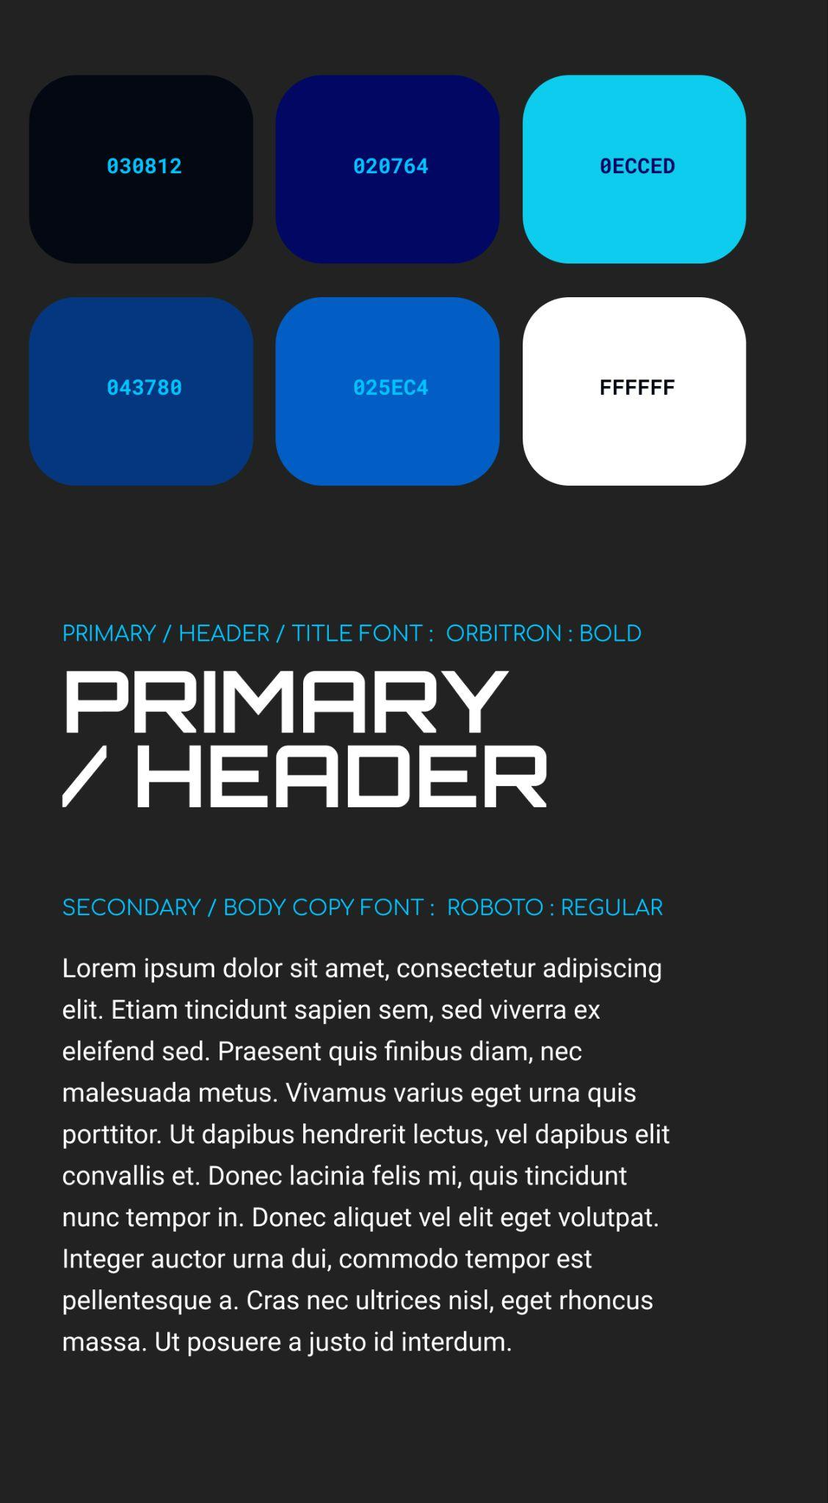

QUSD Brand Identity System

QUSD Brand Identity System

1. Brand Essence
Positioning:
The financial backbone of the autonomous economy — powering AI, IoT, and machine-to-machine payments.
Tone:
Futuristic, reliable, intelligent, precise.
Design Direction:
Aesthetic of advanced technology and trust: deep blues for authority and quantum precision; bright cyan for innovation and digital energy.

2. Color Palette
Color Use | HEX | RGB | Description
Quantum Black | #030812 | (3, 8, 18) | Primary background; evokes deep space and quantum precision.
Core Blue | #020764 | (2, 7, 100) | Primary brand blue; anchors trust and depth.
Spectrum Blue | #043780 | (4, 55, 128) | Secondary tone; used for gradients, hover states, and emphasis.
Signal Blue | #025EC4 | (2, 94, 196) | Highlight color; ideal for CTAs and data visualization.
Neon Cyan | #0ECCED | (14, 204, 237) | Accent color conveys energy, innovation, and digital flow.

Color Usage
- Primary Palette: #030812, #020764
→ Backgrounds, headers, core brand tone.
- Secondary Palette: #043780, #025EC4
→ Interface elements, charts, highlights.
- Accent Palette: #0ECCED
→ Buttons, hover states, data visualizations, links.

Gradient Options
- Quantum Gradient: linear-gradient(135deg, #020764 0%, #025EC4 100%)
- Neural Glow Gradient: linear-gradient(135deg, #025EC4 0%, #0ECCED 100%)

3. Typography System

Primary Typeface — Orbitron
- Use: Headlines, logos, and key calls to action.
- Style: Futuristic, geometric, machine-inspired.
- Weights: Medium (500), Bold (700), Black (900).

Examples:
- H1 (Display): Orbitron Black, 64px — Used in hero titles or landing pages
- H2 (Section Header): Orbitron Bold, 40px — Used for subsections or key messages
- H3 (Feature Title): Orbitron Medium, 28px — Used in cards or UI modules

Secondary Typeface — Roboto
- Use: Body text, UI elements, and supporting content.
- Style: Clean, legible, and highly functional for digital environments.
- Weights: Regular (400), Medium (500), Bold (700).
Examples:
- Body Copy: Roboto Regular, 16px — Used for standard text and descriptions
- Small Text / Captions: Roboto Regular, 14px — For UI labels or tooltips
- Buttons / Navigation: Roboto Medium, 16px — For clarity and accessibility

Typography Hierarchy Example
Element | Typeface | Weight | Size | Use
H1 | Orbitron Black | 900 | 64px | Hero sections / splash screens
H2 | Orbitron Bold | 700 | 40px | Section titles
H3 | Orbitron Medium | 500 | 28px | Feature or content headers
Body | Roboto Regular | 400 | 16px | General content
Caption | Roboto Regular | 400 | 14px | Labels, notes
Button / CTA | Roboto Medium | 500 | 16px | Primary calls-to-action

4. UI/UX Application Guidelines
- Backgrounds: Prefer deep tones (#030812 or #020764) with neon cyan or bright blue accents.
- Text on Dark: White (#FFFFFF) or light gray (#E8E8E8) for contrast.
- Hover / Active States: Animate with #0ECCED glow or gradient transitions.
- Charts / Data: Use gradient between #025EC4 → #0ECCED for visual energy.
- Icons / Lines: Minimal, geometric; light outlines using #0ECCED.

5. Brand Feel Summary
Attribute | Expression
Intelligence | Orbitron + Roboto fusion reflects precision and clarity.
Trust | Deep blue tones build institutional credibility.
Innovation | Neon cyan highlights convey speed, data flow, and AI connection.
Autonomy | Clean, structured layout mirrors the logic of machine-driven transactions.

QUSD Typography System

1. Primary / Header / Title Font
- Font Family: Orbitron
- Weight: Bold
- Usage:
  - Main headers (H1, H2)
  - Page titles, hero sections, key callouts
  - Brand statements, slogans, and taglines
- Characteristics:
  - Futuristic, geometric, tech-forward
  - Strong presence, ideal for digital-first interfaces

2. Secondary / Body Copy Font
- Font Family: Roboto
- Weight: Regular
- Usage:
  - Paragraphs, body text, descriptions
  - UI/UX elements, forms, labels, and captions
  - Whitepapers, articles, and documentation
- Characteristics:
  - Clean, readable, versatile
  - Neutral complement to Orbitron’s bold, technical aesthetic

3. Usage Guidelines
- Headers: Use Orbitron Bold, uppercase preferred for H1/H2 to maintain futuristic impact.
- Subheaders / Highlights: Optionally use Orbitron Medium for smaller headings.
- Body Text: Roboto Regular, 10–14pt for digital content; line height 1.4–1.6 for readability.
- Contrast & Color: Ensure headers are clearly distinguishable from body text using your brand palette (#030812, #020764, #043780, #025EC4, #0ECCED).

